**Lab 9**

**Name :-** Aryan Dilipbhai Langhanoja

**Date :-** 08-08-2023

**Enrollment No :-** 92200133030

**CO1: To write, test, and debug simple Python programs**

**CO2: To implement Python programs with conditional, loops and functions**

**Task 1:- Creating Numpy Array**

**Python Code:**

import numpy as np

a = np.array([1,2,3,4,5])

print(a)

**Output:**

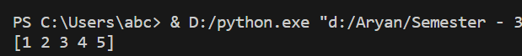

**Task 2:- Accesing The Elements Of Numpy Array**

**Python Code:**

import numpy as np

a = np.array([[1,2,3,4,5],[6,1,2,3,4]])

print(a[1][0])

**Output:**



**Task 3:- Checking The Types of Numpy Array**

**Python Code:**

import numpy as np

a = np.array([1,2,3,4,5])

print(a)

print(type(a))

**Output:**



**Task 4:-** **Creating Zero Matrix Using Numpy**

**Python Code:**

import numpy as np

a = np.zeros((3,2))

print(a)

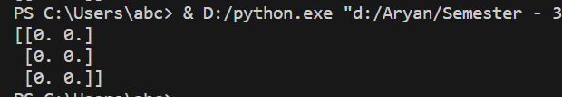**Output:**

**Task 5:- Creating Matrix With all 1’s Using Numpy**

**Python Code:**

import numpy as np

a = np.ones((3,2))

print(a)

**Output:**

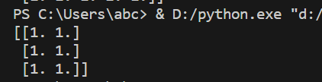

**Task 6:- Initialize Numpy Array With Particular Value**

**Python Code:**

import numpy as np

a = np.full((3,2),6)

print(a)

**Output**

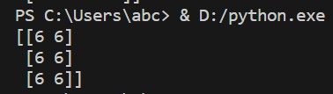

**Task 7:- Element By Element Multiplication of Numpy Array**

**Python Code:**

import numpy as np

a = np.ones((3,2))

b = np.full((3,2),6)

c = a * b

print(c)

**Output:**

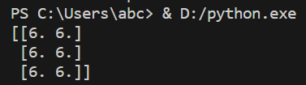

**Task 9:- Implementing Arrange Function**

**Python Code:**

import numpy as np

a = np.arange(10,20)

b = np.arange(0,101,5)

print(a)

print(b)

**Output:**

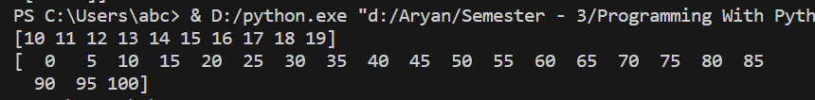

**Task 10:- Generate Random Numbers in given range in Numpy Array**

**Python Code:**

import numpy as np

a = np.random.randint(1,100,10)

print(a)

**Output:**



**Task 11:- Implementing Shape Function**

**Python Code:**

import numpy as np

a = np.array([[1,2,3,4,5],[10,9,8,7,6]])

print(a)

print(a.shape)

a.shape = (5,2)

print(a)

**Output:**

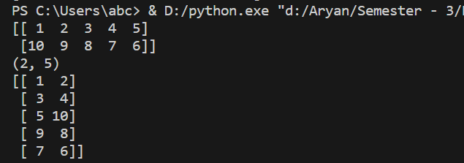

**Task 12:- Implementing Stack Functions**

**Python Code:**

import numpy as np

a = np.array([[1,2,"B",4,5],[10,9,8,7,6]])

b = np.array([["A",9,8,7,6],[1,2,3,4,5]])

print(a)

print(b)

print(np.hstack((a,b)))

print(np.vstack((a,b)))

print(np.column_stack((a,b)))

**Output:**

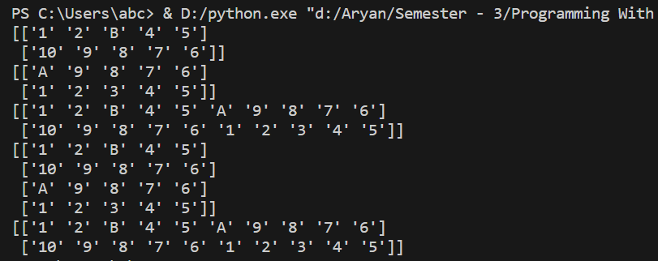

**Task 13:- Intersection And Union Of Numpy Array**

**Python Code:**

import numpy as np

a = np.array([[1,2,3,4,5],[10,9,8,7,6]])

b = np.array([[10,9,8,66,6],[1,2,3,4,5]])

print(np.intersect1d(a,b))

print(np.setdiff1d(a,b))

print(np.setdiff1d(b,a))

**Output:**

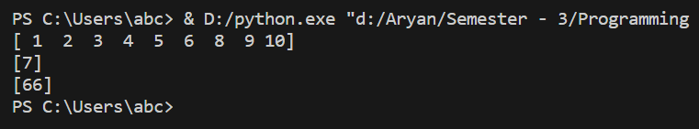

**Task 14:- Arethematics Of Numpy Array**

**Python Code:**

import numpy as np

a = np.array([[1,2,3,4,5],[10,9,8,7,6]])

b = np.array([[10,9,8,66,6],[1,2,3,4,5]])

print(a)

print(b)

print(a+b)

**Output:**

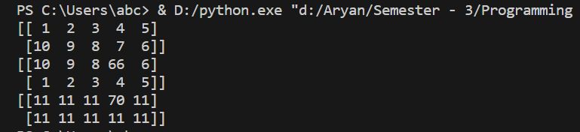

**Task 15:- Adding Two Numpy Array**

**Python Code:**

import numpy as np

a = np.array([10,20])

b = np.array([30,40])

print(np.sum([a,b]))

print(np.sum([a,b],axis=1))

print(np.sum([a,b],axis=0))

**Output:**

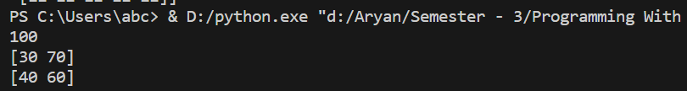

**Post Lab**

**Task 1:- Write a python program to find longest string in the given list**

**l1 = ["ICT","Department","ICT Department"]**

**Python Code:**

list1 = ["ICT","Department","ICT Deparment"]

max = len(list1[0])

for i in range(0,len(list1)) :

if(len(list1[i]) > max) :

max = i

print(f"The Longest Word In A List Is {list1[max]}")

**Output:**

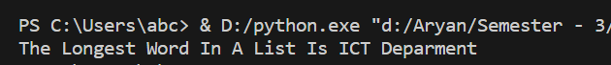

**Task 2:- Write a python program to find the sum of unit digit in the number**

**Python Code:**

l2 = [25,36]

sum = 0

for i in range(0,len(l2)) :

sum = sum + (l2[i]%10)

print(f"The Sum Of All The Unit Digits Is {sum}")

**Output:**



**Task 3:- Write a Python function to find the maximum of three numbers.**

**Python Code:**

max = 0

def max(a,b,c) :

if(a>b) :

if(a>c) :

max = a

else :

max = c

else :

if(b>c) :

max = b

else :

max = c

return max

ans = max(345,567,434)

print(f"The Maximum Is {ans}")

**Output:**



**Task 4:- Write a Python function to sum all the numbers in a list.**

**Python Code:**

def Sum(list1) :

sum = 0

for i in range(0,len(list1)) :

sum = sum + list1[i]

return sum

list2 = [12,23,34,45,56,67,78,89]

listsum = sum(list2)

print(f"The Sum Of All Element In {list2} Is {listsum}")

**Output:**



**Task 5:- Write a Python function to multiply all the numbers in a list.**

**Python Code:**

def Mul(list1) :

mul = 1

for i in range(0,len(list1)) :

mul = mul * list1[i]

return mul

list3 = [98,87,76,65,54,43,32,21]

listmul = Mul(list3)

print(f"The Multiplication Of All Element In {list3} Is {listmul}")

**Output:**

**Task 6:- Write a Python program to reverse a string.**

**Python Code:**

string = input("Enter A String :- ")

print(string[::-1])

**Output:**



**Task 7:- Write a Python function to calculate the factorial of a number (a non-negative integer). The function accepts the number as an argument.**

**Python Code:**

def fact(num) :

ans = 1

for i in range(1,num+1) :

ans = ans * i

return ans

num = int(input("Enter A Number :- "))

ans = fact(num)

if(num>=0) :

print(f"The Factorial Of {num} Is {ans}")

else :

print("Enter The Non-negative Integer")

**Output:**



**Task 8:- Write a Python program to find missing numbers from a list.**

**Input: [1,2,5,10,11,14,17,20]**

**Output: [3,4,6,7,8,9,12,13,15,16,18,19]**

**Python Code:**

list2 = [1,4,5,6,7,9,14,17,20]

listmis = []

for i in range(1,len(list2)) :

for j in range(list2[i-1]+1,list2[i]) :

listmis.append(j)

print(listmis)

**Output:**



**Task 9:- Write a Python program to check a sequence of numbers is an arithmetic progression or not.**

**Input: [1,8,27,64] [1,3,7,2]**

**Output: True False**

**Python Code:**

list1 = []

print("Enter 0 to Exit:- ")

print("Enter Arithmetic Progression :-")

while(True) :

num = int(input())

if(num == 0) :

break

list1.append(num)

def check(num,ref) :

if(num == ref) :

return True

else :

return False

power = math.log(list1[2],3)

anslist = []

for i in range(1,len(list1)) :

anslist.append(check(math.log(list1[i],i+1),power))

j=0

for i in anslist :

if(not i) :

j+=1

break

else :

continue

if(j == 0) :

print("True")

else :

print("False")

**Output:**

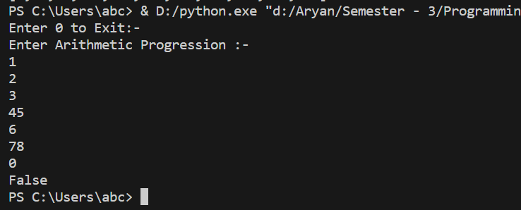

**Task 10:- Write a python program to check whether the given numbers in list is palindrome or not. If palindrome then check number in list is prime or not.**

**Input: [121,132,454,111,147]**

**Python Code:**

def isPalindrome(num) :

s = str(num)

for i in range(0,len(s)) :

if(s[i] != s[len(s)-i-1]) :

return False

else :

continue

return True

def isprime(num) :

prime = True

for i in range(1,num) :

if (num % i == 0) :

prime = False

break

return(prime)

inlist = [121,132,454,111,147]

palindrome = []

prime = []

for i in inlist :

palindrome.append(isPalindrome(i))

if(isPalindrome(i)) :

prime.append(isprime(i))

else :

prime.append(0)

print(palindrome)

print(prime)

**Output:**



**Task 11:- Write a Python program to reverse of numbers from a list of integers, preserving order.**

**Input: [2334,4885,7776,8969]**

**Output: [4332,5884,6777,9698 ]**

**Python Code:**

def revnum(list) :

revnumlist = []

for i in list :

s = str(i)

list = list[1:]

rev = s[::-1]

revnumlist.append(int(rev))

return revnumlist

list = [2334,4885,7776,8969]

ans = revnum(list)

print(ans)

**Output:**



Task 12:- Write a Python program to find the product of the units digits in the numbers of a given list. Input: [12, 23] Output: 6

**Python Code:**

def func(list) :

ans = 1

for i in list :

ans = ans * i%10

return ans

inputlist = [12,23]

ans = func(inputlist)

print(ans)

**Output:**



Task 13:- Write a Python program to remove duplicates from a list of integers, preserving order. Input: [1, 3, 4, 10, 4, 1, 43] Output: [1, 3, ,4, 10, 43]

**Python Code:**

inputlist = [1,3,4,10,4,1,43]

for i in range(0,len(inputlist)) :

for j in range(i + 1,len(inputlist)-1) :

if(inputlist[i] == inputlist[j]) :

del inputlist[j]

print(inputlist)

**Output:**



Task 14:- Write a Python program to find the sum of the even elements that are at odd indices in a given list.  Input: [1,2,3,4,5,6,7] Output: 12

**Python Code:**

list2 = [1,2,3,4,5,6]

sum = 0

for i in range(0,len(list2)) :

if(i%2 != 0 and list2[i]%2==0) :

sum = sum + list2[i]

print(sum)

**Output:**

